中二級 中國歷史科 教學設計示例
(供收錄非華語學生的學校參考使用)
清代盛衰的概況 – 清初到清中葉的發展概況

一.建議教節：3節

二.預期學習成果:
完成本課題後，學生能：
- 了解清朝的統一。（知識內容）
- 認識清初盛世。（知識內容）
- 掌握清代中衰。（知識內容）
- 透過閱讀文字資料、地圖、圖像、影片等，比較異同，分析史事。（知識內容、技能）
- 欣賞康熙帝、雍正帝和乾隆帝開創清朝盛世的開拓和創新精神。（情意、態度）

三.教學建議：
- 因應非華語學生的中文能力，工作紙較多圖像，部分題目輔以英文，協助學生理解內容。
- 題型包括選擇、填充、填表等。思考題可因應學生的語文程度，或以口語回答。
- 教師可按學生學習情況加入討論環節，以增加學生之間的互動。
- 教師可鼓勵學生觀看網上影片及網上博物館資料，提升學習興趣。
- 教師教授課題時，除教授相關史實外，亦須指導學生認識中國的文明和文化，促進他們認識並尊重中國文化的特色。
- 教師可因應學生的程度而選取適合的部份或教學活動施教。

四.教學方案：
內容重點 | 流程 | 相關教材
課節一  清朝的統一 | - 講解關鍵詞  - 運用地圖、時間線、圖像等，說明清朝的建立 | 地圖、  時間線、  圖像、  工作紙
課節二  清初盛世 | - 透過圖像、地圖及影片等，解釋清初盛世 | 圖像、  地圖、  影片、  工作紙
課節三  清代的中衰 | - 透過圖像、網上博物館資料及文字資料等，解釋清代中衰的原因  - 運用地圖、圖像及文字資料等，說明清中葉的內憂外患 | 圖像、  網上博物館資料、  文字資料、  地圖、  工作紙

備註：
- 學校可參考本教學計劃以調適課程內容，以配合學生的需要；
- 可因應學生的中文程度減少或刪去當中的英文句子或詞彙；
- 可同時參考課程發展處出版的其他教材或為本課綱準備的其他示例；
- 可考慮向學生提供更多全方位學習經驗，如實地考察、參觀博物館等等。

XXX中學
中二級 中國歷史科課堂工作紙
清代盛衰的概況 – 清初到清中葉的發展概況
(The overview of the golden ages and the decline of the Qing Dynasty - The development of the early Qing Dynasty to the mid-Qing era)

姓名Name：________________ 成績Grade：_____／_____
班別Class：__________( ) 批改日期 Date of Marking：

學習重點(Learning Objectives)
- 清朝的統一(The Unification of the Qing Dynasty)
- 清初盛世(The Golden ages of the early Qing Dynasty)
- 清代的中衰(The Decline of the Qing Dynasty)

- 本節關鍵詞 (Key Terms)

 | 英文詞彙 | 中文詞彙/粵語拼音 | 中文詞彙/普通話拼音
1 | Qing Dynasty | 清朝(cing1 ciu4) | 清朝(Qīng cháo)
2 | Manchus | 滿族(mun5 zuk6) | 滿族(Mǎn zú)
3 | Golden ages | 盛世(sing6 sai3) | 盛世(shèng shì)
4 | Emperor Kangxi | 康熙帝(hong1 hei1 dai3) | 康熙帝(Kāngxī dì)
5 | Emperor Yongzheng | 雍正帝(jung1 zing3 dai3) | 雍正帝(Yōngzhèng dì)
6 | Emperor Qianlong | 乾隆帝(kin4 lung4 dai3) | 乾隆帝(Qiánlóng dì)
7 | Ten Great Campaigns | 十全武功(sap6 cyun4 mou5 gung1) | 十全武功(shí quán wǔ gōng)
8 | Heshen | 和珅(wo4 san1) | 和珅(Héshēn)
9 | The First Opium War | 第一次鴉片戰爭(dai6 jat1 ci3 aa1 pin3 zin3 zang1) | 第一次鴉片戰爭(dì yī cì yā piàn zhàn zhēng)
10 | The Second Opium War | 第二次鴉片戰爭(dai6 ji6 ci3 aa1 pin3 zin3 zang1) | 第二次鴉片戰爭(dì èr cì yā piàn zhàn zhēng)
11 | The Taiping Rebellion | 太平天國之亂(taai3 ping4 tin1 gwok3 zi1 lyun6) | 太平天國之亂(Tàipíng tiān guó zhī luàn)
12 | Hong Xiuquan | 洪秀全(hung4 sau3 cyun4) | 洪秀全(Hóng Xiùquán)

- 本節概要 (Key Points of the Chapter)

滿族建立清朝。 | The Manchus established the Qing Dynasty.
康熙帝、雍正帝和乾隆帝是清朝的盛世時期。 | The regimes of Emperor Kangxi, Emperor Yongzheng and Emperor Qianlong were the golden ages of the Qing Dynasty.
自乾隆帝後期起，清朝便開始中衰。  清中葉的內憂外患主要包括太平天國之亂、第一次鴉片戰爭和第二次鴉片戰爭。 | Towards the end of Emperor Qianlong’s rule, the Qing Dynasty had already showed signs of decline.  The Taiping Rebellion, the First Opium War and the Second Opium War were the internal problems and external threats of the mid-Qing era.

課節一：清朝的統一 (The Unification of the Qing Dynasty)

清朝是中國最後一個皇朝。(The Qing Dynasty was the last imperial dynasty in China.)
清代是元代以後另一個由外族統治漢人的朝代。清朝的統治者是滿族。(Like the Yuan Dynasty, the Qing Dynasty was one of the eras when Han people were ruled by an ethnic minority, the Manchus.)

資料一：1644年地圖(Source A: The Map of 1644)
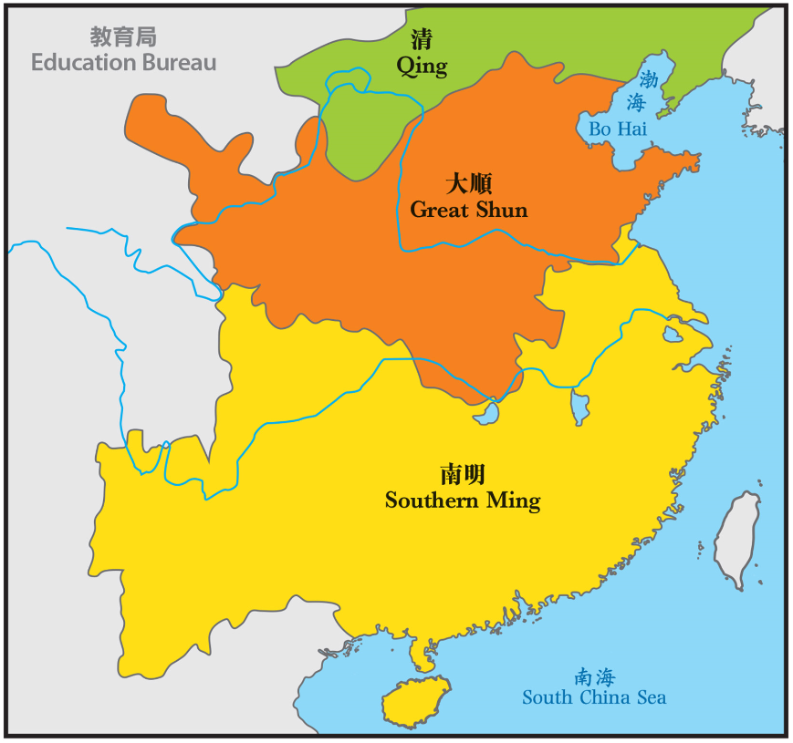
李自成是明末民變領袖。在1644年，他推翻明朝，建立大順。(Li Zicheng was a rebel leader who overthrew the Ming dynasty in 1644 and established the Shun Dynasty.)

1644年明朝滅亡後，大明宗室朱氏在中國南方相繼成立政權，是為南明。(The Southern Ming was a short regime in which several royal members from Zhu clan claimed the rule in southern China following the Ming Dynasty's collapse in 1644.)

資料二：遷界令(Source B: The Great Clearance)
為防止人民給予在台灣的明朝遺臣政權任何接濟，清廷命令沿海居民(包括香港)遷往內陸。(To stop people from collaborating with the Ming loyalists based in Taiwan, the Qing government ordered residents along the coast (including Hong Kong) to move inland.)
香港因而人口大減、土地荒廢、經濟殘破，大批居民流離失所。(As a result, Hong Kong's population was drastically reduced, land was deserted, economy was dilapidated, and a large number of residents were displaced.)

資料三：周王二公書院(Source C:Chau Wong Yi Kung Study Hall)
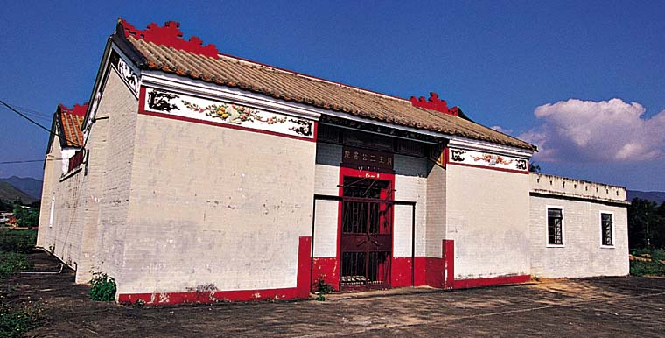
此書院是為供奉清朝廣東巡撫王來任、兩廣總督周有德而建，以報答二人上書朝廷，在1669年成功解除居民遷界之苦。(Chau Wong Yi Kung Study Hall was built in honour of Chou Yu-te and Wang Lai-jen, two imperial officials whose pleading with the emperor to ended the Great Clearance, and this enabled the inhabitants to return to their homes in 1669.)

(圖像來源：https://www.yearbook.gov.hk/1999/b5/gallery/p13_09.htm，觀看日期：2021年7月22日。)

根據資料一至三，回答以下問題。(Study Sources A to C, and answer the questions.)

1. 根據資料一及二，滿清需要消滅哪些敵對勢力，才能完全統一全國？請圈出答案。(Study Sources A and B, what resistance forces did Manchus need to eliminate in order to unify the whole country? Circle your answer.)
A. 南明統治者(Southern Ming rulers)
B. 民變領袖李自成(Rebel leader - Li Zicheng)
C. 佔領了台灣島的明朝遺臣(The Ming loyalists who occupied Taiwan)
D. 以上皆是(all of above)
2. 香港有一條「巡撫街」，是紀念王來任和周有德而建的。它在哪一地區？請圈出答案。(Hong Kong has a street called Tsun Fu Street and it was built in honour of Chou Yu-te and Wang Lai-jen. Where is it? Circle your answer.)
A. 灣仔(Wan Chai)
B. 沙田(Sha Tin)
C. 上水(Sheung Shui)
D. 九龍塘(Kowloon Tong)

3. 為甚麼香港人要紀念他們？(Why do Hong Kong people commemorate them?)
報答他們上書朝廷，成功解除居民遷界之苦。(This is because they pleaded with the emperor to end the Great Clearance and this enabled the inhabitants to return to their homes.)

資料四：清初到清中葉時間線及世系表(Source D:The timeline and lineage of the early Qing Dynasty to the mid-Qing)

AD
公元

J

K
C
I
H
B
A

 |  |  | D |  |  | E |  | F |  |  | G
1610 1640 1670 1700 1730 1760 1790 1820 1850 1880

4. 在時間線上用「A」至「K」標示相關的歷史事件 / 時期。(Please mark the historical events / periods “A” to “K” on the timeline.)

 | 皇帝(Emperor) | 統治時期(年)Reign Time (years) | 重要歷史事件 / 時期(Important historical events / periods)
1 | 清太祖(努爾哈赤) (Emperor Taizu (Nurhaci)) | 1616 – 1626 | A. 公元1616年，女真族的領袖 -努爾哈赤建立後金。(In 1616, The leader of the Jurchen tribes, Nurhaci, founded Later Jin Dynasty.)
2 | 清太宗(皇太極) (Emperor Taizong (Hong Taiji)) | 1626 – 1643 | B. 公元1636年，皇太極改族名為滿族，改國號為大清。(In 1636, Emperor Taizong called his people the Manchus and renamed his dynasty Qing.)
3 | 順治帝(Emperor Shunzhi) | 1643 – 1661 | C. 公元1644年，滿清入關，建立清朝。(In 1644, the Manchus crossed the Great Wall and established the Qing Dynasty.)
4 | 康熙帝(Emperor Kangxi) | 1661 – 1722 | D. 清朝盛世(The golden ages of the Qing Dynasty)
5 | 雍正帝(Emperor Yongzheng) | 1722 – 1735 | E. 清朝盛世(The golden ages of the Qing Dynasty)
6 | 乾隆帝(Emperor Qianlong) | 1735 – 1796 | F. 清朝盛世(The golden ages of the Qing Dynasty)  清朝開始衰落(The Qing Dynasty started to decline)
7 | 嘉慶帝(Emperor Jiaqing) | 1796 – 1820 | G. 清朝衰落(The decline of the Qing Dynasty)
8 | 道光帝(Emperor Daoguang) | 1820 – 1850 | H. 公元1840，第一次鴉片戰爭爆發。(In 1840, the First Opium War broke out.)
9 | 咸豐帝(Emperor Xianfeng) | 1850 – 1861 | I. 公元1851，洪秀全起事，建號太平天國。(In 1851, Hong Xiuquan started an uprising and established the Taiping Heavenly Kingdom.)  J. 公元1856，第二次鴉片戰爭爆發。(In 1856, the Second Opium War broke out.)
10 | 同治帝(Emperor Tongzhi) | 1861 – 1875 | K. 公元1864，太平天國滅亡。(In 1864, the Taiping Heavenly Kingdom was defeated.)

根據資料四，回答以下問題。(Study Source D, and answer the questions.)

5. 清朝是由哪一個民族所建立的政權？試圈出答案。(Which ethnic group established the Qing Dynasty? Circle your answer.)
A. 蒙古(Mongol)
B. 回族(Hui)
C. 漢族(Han)
D. 滿族(Manchus)

6. 哪三位皇帝在位時期是清朝的盛世？(Who reigned during the golden ages of the Qing Dynasty? Please write down the names of the three emperors.)
康熙帝、雍正帝和乾隆帝(Emperor Kangxi, Emperor Yongzheng and Emperor Qianlong)

7. 這三位皇帝共統治了多少年？(寫出算式)。(Please calculate how long these three emperors of the Qing Dynasty ruled (write down the equations).)
1796 – 1661 = 135 年years

資料五：滿族的髮型和服飾(Source E: Hairstyles and clothings of Manchus)
光禿禿的前額和一根長長的辮子(a bare forehead and a single long braid of hair)
高高的大拉翅(tall headdress)
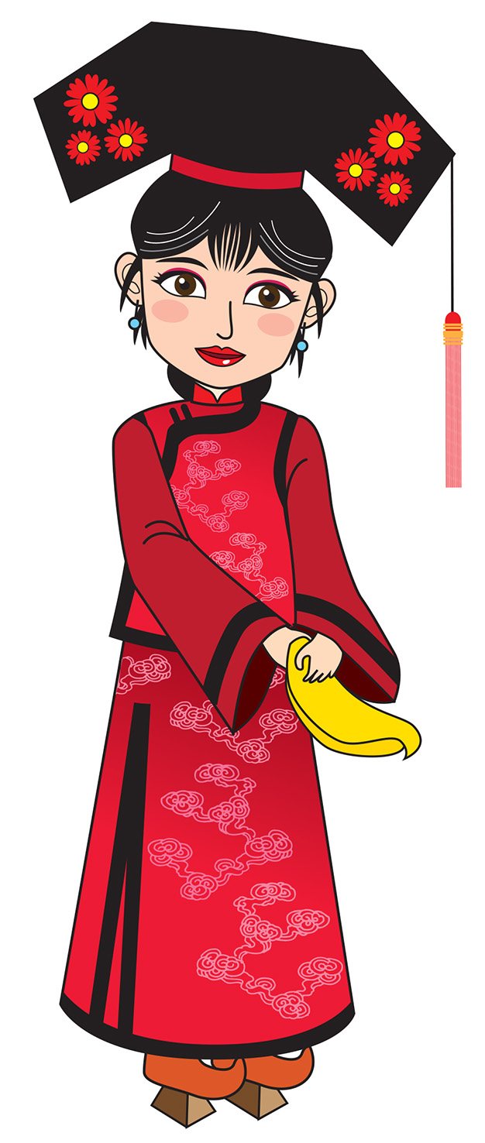

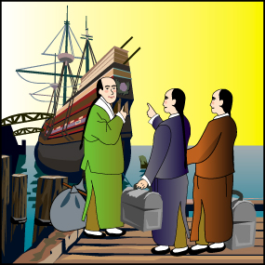

袍服(robes)

高底鞋(Shoes with raised bottom)

8. 請畫上你們的民族服飾。(Please draw the folk costumes of your ethnic groups.)

課節二：清初盛世(The golden ages of the early Qing Dynasty)

清初盛世由康熙帝開始，然後是雍正帝，接著是乾隆帝。(The golden ages of the Qing Dynasty began with Emperor Kangxi, followed by Emperor Yongzheng and then Emperor Qianlong.)

I. 康熙帝(Emperor Kangxi)

資料一：康熙帝與路易十四 (Source A:Emperor Kangxi and Louis XIV)
十七世紀中後期至十八世紀初，中國和法國分別由康熙帝和路易十四統治。他們都被認為是各自國家最偉大的統治者。我們一起探索同一時代的兩位皇帝吧！(In the latter half of the 17th and the early 18th centuries, China was ruled by Emperor Kangxi, while Louis XIV ruled France. They were regarded as the greatest rulers in their respective countries. Let’s explore two emperors in the contemporary time!)

 | 清朝(The Qing Dynasty) | 法國(France)
皇帝  (Emperor) | 康熙帝(Emperor Kangxi)  1661 – 1722在位(reigned)  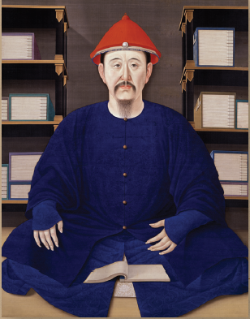  (圖像來源：「國采朝章 – 清代宮廷服飾」展覽小冊子，香港：香港歷史博物館，頁4。) | 路易十四(Louis XIV)  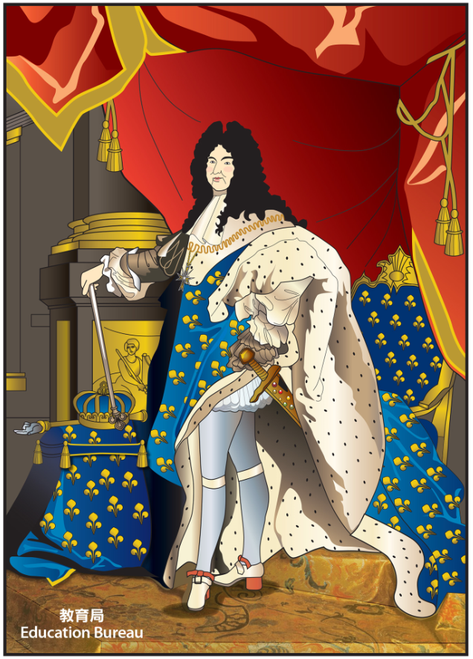  1643 – 1715在位(reigned)

 | 康熙帝(Emperor Kangxi)  1661 – 1722在位(reigned) | 路易十四(Louis XIV)  1643 – 1715在位(reigned)
請觀看(Please view) | https://achist.mers.hk/chihistoryanime/download/eng/animate/eduhk_chihst_anime_16_s1_eng_sd.mp4  (英文English)  https://achist.mers.hk/chihistoryanime/download/can/animate/eduhk_chihst_anime_16_s1_can_sd.mp4 (中文Chinese) | https://www.youtube.com/watch?v=SEjiw6ipwnU

資料二：《皇輿全覽圖》(Source: B: The Kangxi Imperial Atlas of China)
康熙帝與路易十四兩位君主通過法國耶穌會士間接地連繫著。(Emperor Kangxi and Louis XIV were indirectly connected by the French Jesuits.)
這幅地圖由中國官員和耶穌會士花了十年時間繪製而成。(Chinese officials and Jesuits spent 10 years to draw this map.)
請觀看(Please view)
https://www.dpm.org.cn/ancient/special/143156.html
(故宮博物院 The Palace Museum)

根據資料一及二，回答以下問題。(Study Sources A and B, and answer the questions.)

1. 根據影片，康熙帝為了把權力收回手中，他清除了哪位權臣？請圈出答案。(According to the video, in order to concentrate the power in his own hands, which of the following powerful courtier did Emperor Kangxi eliminate? Circle your answer.)
A. 索尼(Sonin)
B. 鰲拜(Oboi)
C. 蘇克薩哈(Suksaha)
D. 遏必隆(Ebilun)

2. 根據影片，康熙帝有甚麼貢獻？請圈出答案。(According to the video, which of the following achievements did Emperor Kangxi have? Circle your answer.)
A. 鞏固中國版圖(To consolidate the territories of China)
B. 承傳中華文化(To inherit the Chinese culture)
C. 學習西方科學(To study science from the West)
D. 以上皆是 (all of above)

3. 康熙帝與路易十四有甚麼相似的地方？請填寫下表。(What were the similarities between Emperor Kangxi and Louis XIV? Please fill in the following table.)

康熙帝(Emperor Kangxi) | 路易十四(Louis XIV)
從 8 歲起做皇帝，一共做了 61 年。(He was the emperor for 61 years starting from 8 years old.) | 從 5 歲起做皇帝，一共做了 73 年。(He was the emperor for 73 years starting from 5 years old.)
中國歷史上在位時間最長的皇帝。(One of the longest reigning emperors in the Chinese history) | 歐洲歷史上在位時間最長的君主。(One of the longest reigning monarchs in Europe)
康熙帝開創了盛世。(Emperor Kangxiu started the golden ages.) | 路易十四在位時，法國處於最強大的時期。(France was the strongest when Louis XIV was in power.)

4. 清朝用了多少年時間繪製《皇輿全覽圖》？(How many years did the Qing Dynasty spend to draw the Kangxi Imperial Atlas of China?)
10年(years)

II. 雍正帝(Emperor Yongzheng)

資料三：雍正帝(Source C: Emperor Yongzheng)
雍正帝(1722 – 1735)有效地延續了清朝的繁榮時期。(Emperor Yongzheng (1722 – 1735) maintained the prosperity of the Qing Dynasty.)
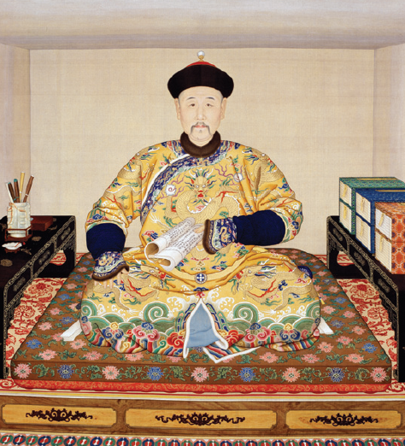

(圖像來源：「國采朝章 – 清代宮廷服飾」展覽小冊子，香港：香港歷史博物館，頁4。)

資料四：動畫版《雍正行樂圖》(Source D: Flash animations of the Paintings of Amusement of Emperor Yongzheng)
故宮博物院的工作人員運用科技，製作出動畫版的《雍正行樂圖》。畫中的雍正帝穿著洋服、漢服、滿服等不同服飾。(The flash animations are made by technicians from the Palace Museum based on the Paintings of Amusement of Emperor Yongzheng. In the animations, Emperor Yongzheng wore various costumes, such as the costumes of foreign countries, Han, Manchus, etc.)
請觀看(Please view)
http://www.chinadaily.com.cn/culture/2014-08/05/content_18250346.htm

5. 活動：皇帝的袍服(Activity: robe of the emperor)
請為雍正帝重新設計一件袍服。(Please help design a new robe for Emperor Yongzheng.)
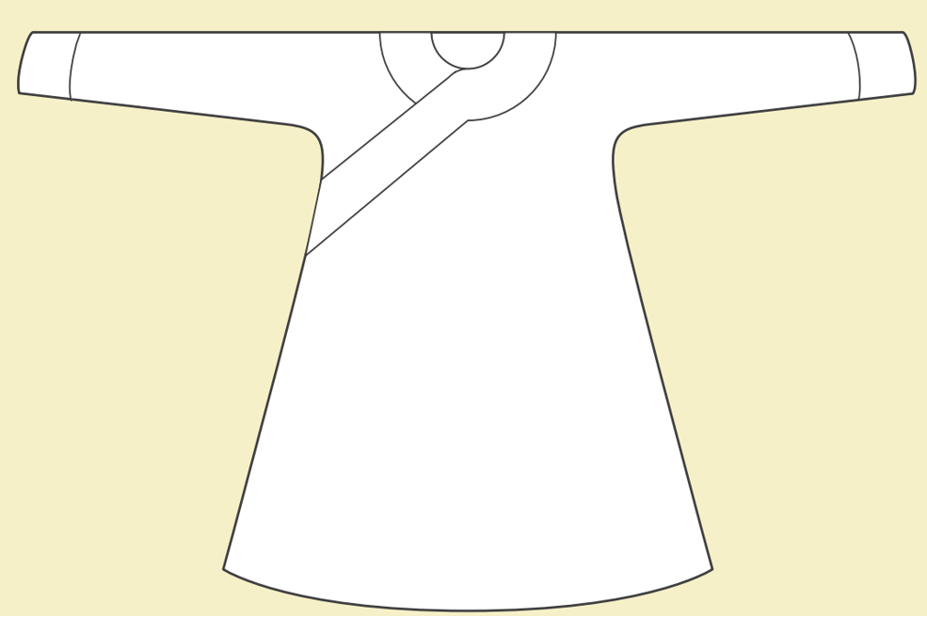

(圖像來源：「天子‧公民─末代皇帝」工作紙，香港：香港海防博物館，頁2。)

III. 乾隆帝(Emperor Qianlong)

資料五：乾隆帝(Source E:Emperor Qianlong)
乾隆帝(1735-1796)進一步鞏固了清朝的管治。乾隆年間人口迅速增長，藝術及文化興盛。(Emperor Qianlong (1735 – 1796) further strengthened the empire. Under Emperor Qianlong, population in China increased rapidly. Arts and culture flourished at that time.)
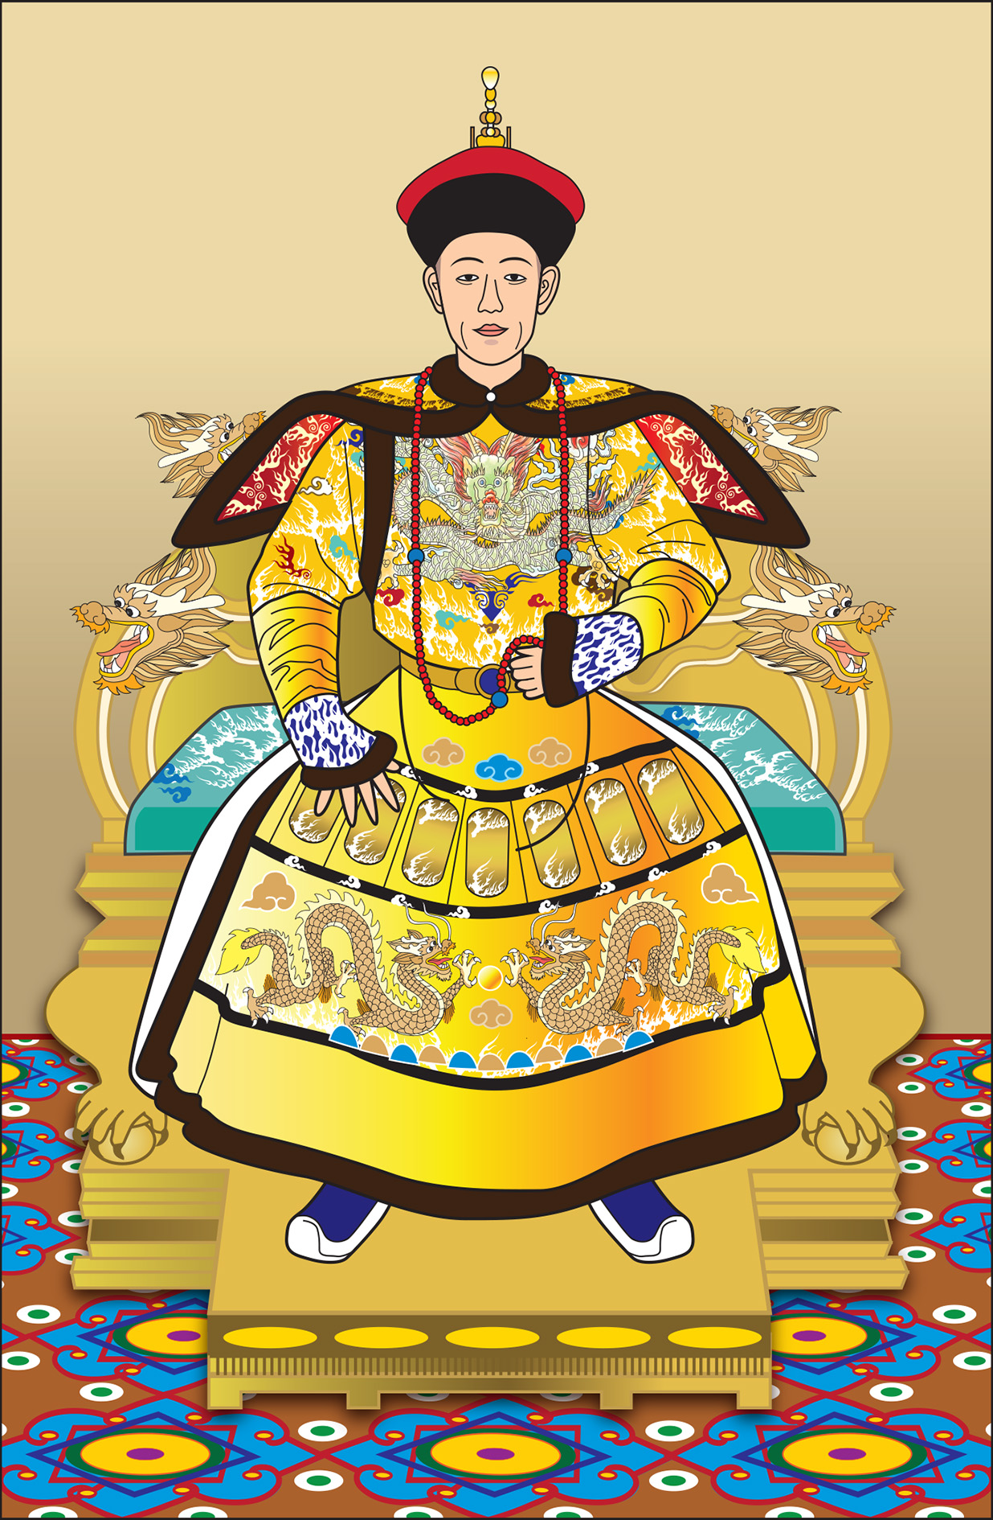

(圖像來源：教育局課程發展處《想．創—中國歷史學與教資源套（第二輯）》。)

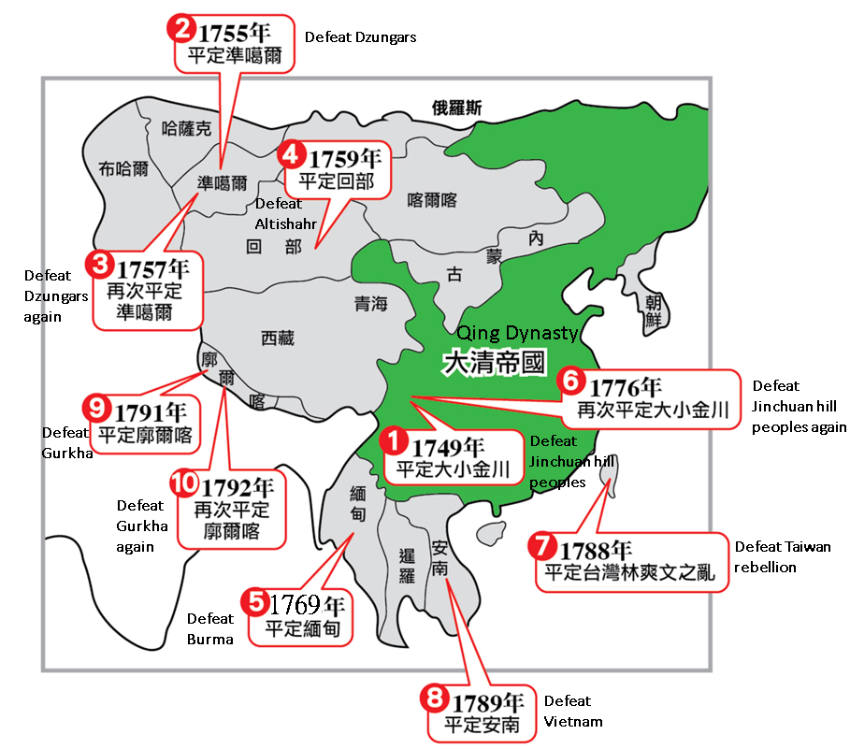
資料六：乾隆帝十全武功圖(Source F: The map of Ten Great Campaigns of Emperor Qianlong)

6. 根據資料六，乾隆帝十全武功令清朝擴展勢力至：(請圈出答案)(Study Source F, the Ten Great Campaigns of Emperor Qianlong extended Qing’s control into: (Circle your answer.))
A. 中亞(Central Asia)
B. 西域(The Western Regions)
C. 歐洲(Europe)
D. 非洲(Africa)

小總結 (A short summary)
滿族建立清朝。(Manchus established the Qing Dynasty.)
清朝頒布遷界令，香港地區也受到影響。(Hong Kong region was affected by the Great Clearance of the Qing Dynasty.)
在康熙帝、雍正帝和乾隆帝的統治下，中國經歷了一段長時間的安穩繁榮的日子。(China had experienced a long period of peace and prosperity under the rules of the three great emperors, Emperor Kangxi, Emperor Yongzheng and Emperor Qianlong.)
課節三：清代的中衰(The Decline of the Qing Dynasty)
清朝在康熙帝、雍正帝、乾隆帝三朝雖號稱盛世，但自乾隆後期起，便開始中衰。(Although the Qing Dynasty experienced golden ages during the reigns of the Emperor Kangxi, Yongzheng, and Qianlong, the empire had already showed signs of the decline at the end of Emperor Qianlong’s rule.)

I. 清代的中衰(The Decline of the Qing Dynasty)

資料一：《乾隆大閱圖》(Source A: The Qianlong Emperor in Ceremonial Armor on Horseback)
乾隆皇帝發動了一系列的軍事行動，以擴大清的領土，軍費支出龐大。(Emperor Qianlong launched a series of military campaigns to expand the territories of Qing. Frequent military expeditions caused heavy expenses.)
這幅畫中，乾隆皇帝身穿鎧甲檢閱清軍。(Emperor Qianlong wore armor and attended the military parade in the painting.)
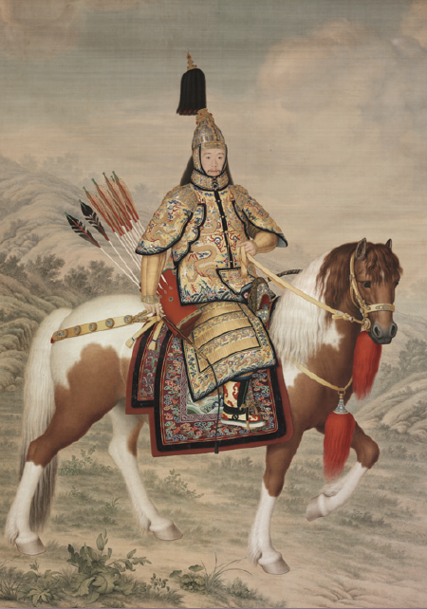

(圖像來源：「國采朝章 – 清代宮廷服飾」展覽小冊子，香港：香港歷史博物館，頁5。)

請觀看(Please view)
https://en.dpm.org.cn/collections/collections/2013-09-26/1009.html
附有英文簡介(with English introduction)
(故宮博物院 The Palace Museum)
資料二：《崇慶皇太后萬壽慶典》(Source B: Painting of the Birthday Celebration of Empress Dowager Chongqing)
乾隆帝為母親慶祝生日，花費很大。(Emperor Qianlong spent generously to organize a grand birthday celebration for his mother.)
這幅畫描繪了乾隆帝為母親崇慶皇太后慶祝生日的情況。(This painting depicts that Emperor Qianlong organized a grand birthday celebration for his mother, Empress Dowager Chongqing.)
請觀看(Please view)
https://www.dpm.org.cn/collection/paint/232815.html?hl=%E5%85%AB%E6%97%AC%E4%B8%87%E5%AF%BF%E7%9B%9B%E5%85%B8
(故宮博物院 The Palace Museum)

1. 活動(Activity)：
中國民間傳統為長壽老人慶祝生日時，會準備各種寓意長壽的食品，例如壽桃、壽麫等。(According to the Chinese custom, various kinds of food stuffs conveying the wish for longevity, such as “longevity peaches” and “longevity noodle”, would be prepared to celebrate the elders’ birthdays.)
你們國家有甚麼象徵長壽的禮物？(What kinds of presents that signify “longevity” in your country?)
請你幫乾隆帝設計一件具特色的生日禮物送給他的母親。請把你的構思畫出來吧！(Please help Emperor Qianlong design a special birthday gift for his mother. Put down your idea in drawing!)

資料三：和珅(Source C:Heshen)
乾隆後期，貪污盛行。乾隆帝寵信和珅，他是中國最著名的貪官。(Rampant corruptions occurred during the later years of Emperor Qianlong's reign. Emperor Qianlong trusted Heshen. He was the most corrupt official in the Chinese history.)
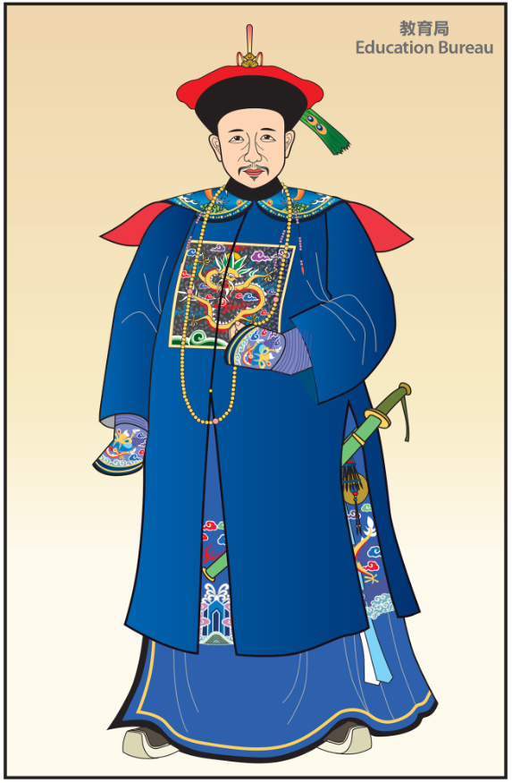

2. 和珅是哪一位清朝皇帝時期的貪官？請圈出答案。(Which period did the most corrupt official in the Qing Dynasty, Heshen, live? Circle your answer.)
A. 康熙帝(Emperor Kangxi)
B. 雍正帝(Emperor Yongzheng)
C. 乾隆帝(Emperor Qianlong)
D. 嘉慶帝(Emperor Jiaqing)

根據資料一至三，回答以下問題。(Study Sources A to C, and answer the questions.)

3. 清代的中衰從哪一位皇帝開始？請圈出答案。(Who marked the beginning of the decline of the Qing Dynasty? Circle your answer.)
A. 康熙帝(Emperor Kangxi)
B. 雍正帝(Emperor Yongzheng)
C. 乾隆帝(Emperor Qianlong)
D. 嘉慶帝(Emperor Jiaqing)

4. 以下哪一項不是乾隆後期財政支出龐大的原因？請圈出答案。(Which of the following was not the reason concerning the great expenditure at the end of Emperor Qianlong’s rule? Circle your answer.)
A. 連年用兵，軍費支出龐大(Frequent military expeditions)
B. 每年向邊境民族進貢(Tribute to the frontier ethnic groups)
C. 乾隆揮霍無度(Extravagance and luxury of Emperor Qianlong)
D. 貪污成風，官吏中飽私囊(Rampant corruptions of government officials)

資料四：清中期的人口增長(Source D: Population growth in the mid-Qing era)

年(Year) | 人口(Population)
1741 (乾隆6年) (6th year of Emperor Qianlong’s reign) | 1.4億(140 million)
1793 (乾隆58年) (58th year of Emperor Qianlong’s reign) | 3.7億(370 million)
1850 (道光30年) (30th year of Emperor Daoguang’s reign) | 4.3億(430 million)

(資料來源：https://www.edb.gov.hk/attachment/tc/curriculum-development/kla/pshe/references-and-resources/chinese-history/cheung_outline1.pdf，觀看日期：2021年9月15日。)

資料五：根據人口普查，在英國統治下的印度人口(包括現在的巴基斯坦和孟加拉國)：(Source E: According to the census, the population of India under British Raj (including now Pakistan and Bangladesh)

人口普查年(Census year) | 人口(Population)
1871 | 2.39億(239 million)
1881 | 2.54億(254 million)
1891 | 2.87億(287 million)
1901 | 2.94億(294 million)

(資料來源：https://tw.amznwiki.com/999948-india-demographics-YCSART，觀看日期：2021年9月15日。)

根據資料四及五，回答以下問題。(Study Sources D and E, and answer the questions.)

5. 從1741年至1850年，清朝人口增加了2.9億，增幅超過2倍。(From 1741 to 1850, the population of the Qing Dynasty increased by 290 million, more than 2 times.)

6. 以下哪項不是清中期人口大增所產生的問題？請圈出答案。(Which of the following was not a problem arising from the sharp increase in population in the mid-Qing era? Circle your answer.)
A. 耕地不足(Inadequate cultivated lands)
B. 糧食短缺(Food shortage)
C. 物價上升(Rising prices)
D. 造成資源的浪費(A waste of resources)

7. 在19世紀，中國 / 印度 的人口較多。(請圈出答案。)(In the 19th century, China / India had a larger population. (Circle your answer.))

8. 請填寫以下國家現時的人口數目。(Please fill in the current population of the following countries.)
國家(country) | 人口(Population)
中國(China) | 約14.5億(about 1.45 billion)
印度(India) | 約14億(about 1.4 billion)
巴基斯坦(Pakistan) | 約2.3億(about 230 million)
孟加拉國(Bangladesh) | 約1.7億(about 170 million)
(以上答案只供參考。(The above answers are for reference only.))
(資料來源：https://countrymeters.info/cn/World，觀看日期：2021年9月15日。)

9. 根據資料一至四，下列哪一項不是導致清朝中衰的原因？請圈出答案。(Study Sources A to D, which of the following was not the reason for the decline of the Qing Dynasty? Circle your answer.)
A. 三藩叛亂，削弱統治(Revolt of the Three Feudatories weakened the rule)
B. 征戰頻繁，軍費浩大(Frequent military expeditions caused heavy expenses)
C. 皇室浪費，國庫空虛(Extreme imperial extravagance and luxury contributed to great expenditure)
D. 人口大增，耕地不足 (Sharp population increase led to shortages of cultivated lands)
E. 貪污成風，吏治敗壞(Rampant corruptions led to poor administrations)

小總結 (A short summary)
由於貪污成風、征戰頻繁、人口大增、君主揮霍，清朝在乾隆晚期開始衰落。(Towards the end of Emperor Qianlong’s rule, signs of empire’s decline had already emerged as there were rampant corruptions, frequent military campaigns, sharp population increase, and extreme imperial extravagance.)

II. 清中葉的內憂外患(Internal problems and external threats of the mid-Qing era)

內憂外患導致清朝衰落。(Internal problems and external threats led to the fall of the Qing Dynasty.)

資料六：清中葉的內憂外患概況(Source F: The overview of the internal problems and external threats of the mid-Qing era)
內憂(Internal problems) | 年份(Years) | 外患(External threats)
 | 1839 | 第一次鴉片戰爭爆發(The First Opium War broke out.)
 | 1842 | 第一次鴉片戰爭結束(The First Opium War ended.)  《南京條約》簽訂(The Treaty of Nanking was signed.)
洪秀全起事，建號太平天國(Hong Xiuquan started an uprising and established the Taiping Heavenly Kingdom.) | 1851
 | 1856 | 第二次鴉片戰爭爆發(The Second Opium War broke out.)
 | 1858 | 英法聯軍攻陷大沽口(The British and French armies captured Dagukou.)  《天津條約》簽訂(The Treaty of Tianjin was signed)
 | 1860 | 第二次鴉片戰爭結束(The Second Opium War ended.)  《北京條約》簽訂(The Convention of Peking was signed)
太平天國敗亡(The Taiping Heavenly Kingdom was defeated.) | 1864

根據資料六，回答以下問題。(Study Source F, and answer the questions.)

10. 以下哪些是清中葉的內憂外患？試圈出答案。答案可多於一個。(Which of the following were the internal problems and external threats of the mid-Qing era? Circle your answer. There may be more than one correct answer.)
A. 甲午戰爭(The First Sino-Japanese War)
B. 第一次鴉片戰爭(The First Opium War)
C. 第二次鴉片戰爭(The Second Opium War)
D. 太平天國之亂(The Taiping Rebellion)
E. 八國聯軍之役(The Eight-Power Expedition)
F. 三藩之亂(Revolt of the Three Feudatories)

11.太平天國之亂持續了多少年(寫出算式)？(How long did the Taiping Rebellion last for? (Write down the equations).)
1864 – 1851 = 13 年years

12. 哪些是清中葉內憂外患的影響？試圈出答案。(What were the impacts of the internal problems and external threats of the mid-Qing era? Circle your answer.)
A. 削弱清朝的中央集權(The power of the Qing government weakened)
B. 簽訂了代價高昂和屈辱的條約(Costly and humiliating treaties were signed)
C. 暴露清朝政治軍事的積弱(The political and military weaknesses of the Qing Dynasty were exposed)
D. 以上皆是(all of above)

資料七：太平天國之亂(Source G:The Taiping Rebellion)
請觀看2:07-8:01 (Please view 2:07-8:01)
https://www.pbslearningmedia.org/resource/taiping-rebellion-story-of-china/taiping-rebellion-story-of-china/

13. 根據資料七，甚麼原因促使太平天國之亂的發生？試圈出答案。(Study Source G, which of the following factors led to the rise of the Taiping Rebellion? Circle your answer.)
A. 人口大增，耕地不足(Enormous population growth and inadequate cultivated lands)
B. 經濟及社會困難(Economic and social setbacks)
C. 在第一次鴉片戰爭中戰敗(Defeat in the First Opium War)
D. 貪污成風，吏治敗壞(Rampant corruptions of officials and poor administration)
E. 以上皆是(all of above)

14. 在對抗清廷的戰事中，太平天國面對多方面的軍事威脅，你知道他們是誰嗎？(The Taiping Heavenly Kingdom fought with different parties. Do you know the enemies of the Taiping Heavenly Kingdom?)
A.戈登(Charles George Gordon) B.李鴻章(Li Hongzhang)
C.曾國藩(Zeng Guofan)
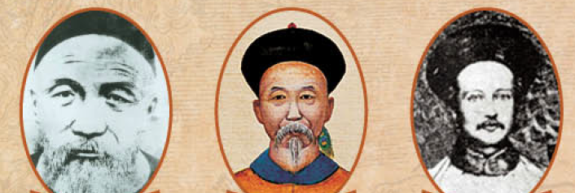
A. 戈登
(Charles George Gordon)
常勝軍統領人
(Leader of the Ever Victorious army)
B. 李鴻章
(Li Hongzhang)
淮軍統領人
(Leader of the Huai army)
C. 曾國藩
(Zeng Guofan)
湘軍創建人
(Founder of the Xiang army)

(圖像來源：「太平天國文物展教育子冊子」，香港：香港海防博物館，頁5)

15. 根據資料七，太平天國之亂主要造成多少人死亡？(Study Source G, what was the major impact of the Taiping Rebellion?)
超過2千萬人死亡(Over 20 million people died)

資料八：《資政新篇》(Source H:The New Essay on Economics and Politics)
太平天國干王洪仁玕於1852至1858年期間曾居於香港。(Hong Ren'gan, later Shield King, stayed in Hong Kong for several years from 1852 to 1858.)
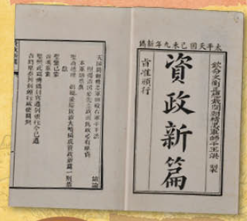
他結合在香港及上海多年的所見所聞，撰成《資政新篇》，以闡述治國理念，針對時弊。(He consolidated his knowledge and experience gained in Hong Kong and Shanghai, and expounded his ideas of governance in "The New Essay on Economics and Politics". The reforms mentioned in the book were regarded as forward-thinking as they intended to tackle the problems of China at that time.)

(圖像來源：「太平天國文物展教育子冊子」，香港：香港海防博物館，頁5)

16. 哪位太平天國的王曾於香港居住？請圈出答案。(Which King of the Taiping Heavenly Kingdom lived in Hong Kong temporarily? Circle your answer.)
A. 天王洪秀全(Heavenly King, Hong Xiuquan)
B. 干王洪仁玕(Shield King, Hong Ren'gan)
C. 翼王石達開(Assistant King, Shi Dakai)
D. 南王馮雲山(South King, Feng Yuansahn)

資料九：條約與香港(Source I: Treaties and Hong Kong)
圖一《南京條約》(The Treaty of Nanking)
一因
大英商船遠路涉洋往往有損壞須修補者自應給予沿海一處以便修船及存守所用
物料今
大皇帝准將香港一島給予
大英
君主暨嗣後世襲主位者常遠據守主掌任便立法治理
Article 3
It being obviously necessary and desirable, that British Subjects should have some Port whereat they may careen and refit their Ships, when required, and Keep Stores for that purpose, His Majesty the Emperor of China cedes to Her Majesty the Queen of Great Britain, &c., the Island of Hong-Kong, to be possessed in perpetuity by Her Britannic Majesty, Her Heirs and Successors, and to be governed by such Laws and Regulations as Her Majesty the Queen of Great Britain, &c., shall see fit to direct.

圖二《北京條約》(The Convention of Peking)
Article VI
With a view to the maintenance of law and order in and about the harbour of Hong Kong, His Imperial Majesty the Emperor of China agrees to cede to Her Majesty the Queen of Great Britain and Ireland. and to Her heirs and successors, to have and to hold as a dependency of Her Britannic Majesty's Colony of Hong Kong, that portion of the township of Kowloon. in the Province of Kwang-tung

第六款
前據本年二月二十八日
大清兩廣總督勞崇光將粵東九龍司地方一區交
與大英駐紮粵省暫充英法總局正使功賜三等
寶星巴夏禮代國立批永租在案茲
大清大皇帝定即將該地界付與大英大君主並歷
後嗣並歸英屬香港界內以期該港埠面管轄
所及庶保無事其批作為廢紙外其有該地華
民自稱業戶應由彼此兩國各派委員會勘查
明果為該戶本業嗣後倘遇勢必令遷別地大
英國無不公當賠補
第七款
一戊午年所定原約除現定續約或有更張外

17. 清朝戰敗，被迫簽署條約及割讓香港島和九龍半島。(The Qing Dynasty was defeated. Treaties were signed and Hong Kong Island and Kowloon Peninsula were ceded.)
請填寫被割讓的地方及相關條約的名稱。(Please fill in the places that were ceded and the names of related treaties.)
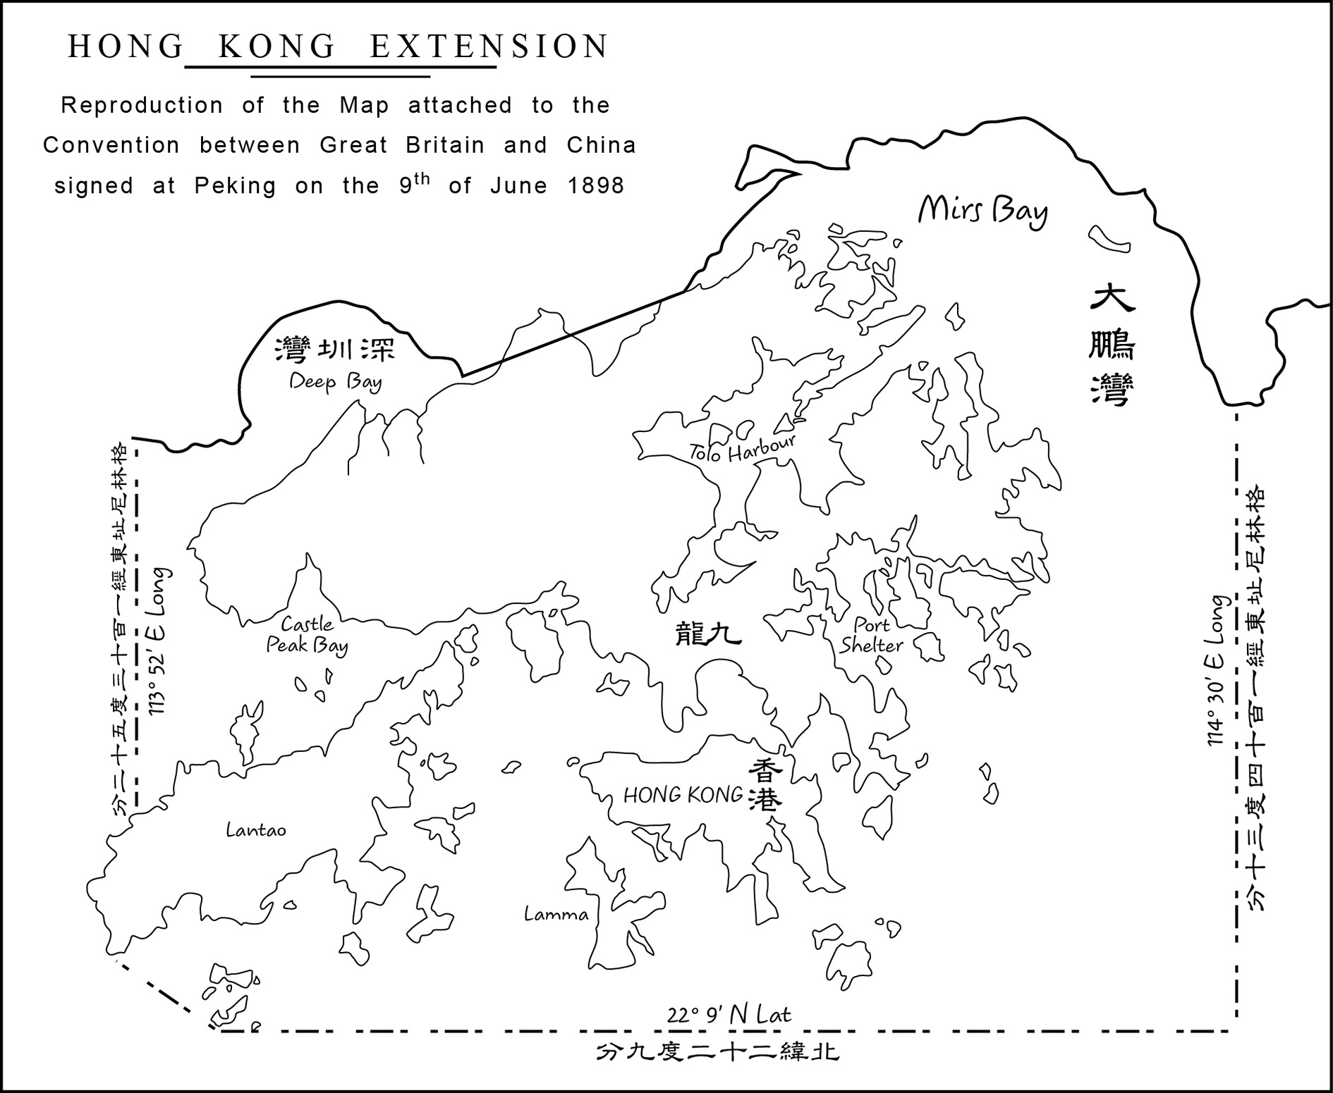
(圖像來源：教育局課程發展處《想．創—中國歷史學與教資源套（第二輯）》。)

戰役(War) | 英國割佔的地方(The place was occupied by Britain) | 相關條約(Related Treaty)
第一次鴉片戰爭  (The First Opium War) | 香港島  (Hong Kong Island) | 《南京條約》  (The Treaty of Nanking)
第二次鴉片戰爭  (The Second Opium War) | 九龍半島  (Kowloon Peninsula) | 《北京條約》  (The Convention of Peking)

18. 請在地圖上圈出你現在居住的地方。(Please circle the place that you live on the map.)學生可以自由作答。

資料十：西方列強在亞洲的侵略(Source J: Invasion of western powers in Asia)
不同的西方列強曾侵略亞洲。(Different western powers invaded Asia.)

19.地圖顯示曾被西方列強侵略的位置，請在方格填上西方列強的英文代號。(The map showed the locations that were invaded by western powers .Please write down the appropriate letters of western powers in the boxes.)
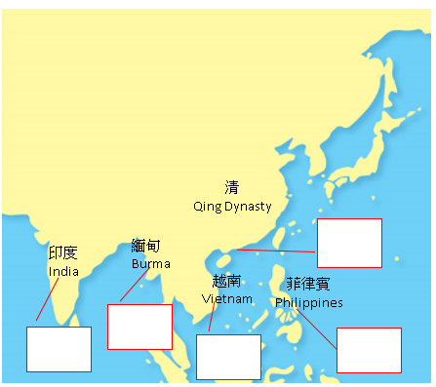

侵略者(invader) | 地方(place) | 侵略時期(invasion period)
A. 西班牙(Spain) | 菲律賓(The Philippines) | 1565年－1898年
B. 英國(Britain) | 緬甸(Burma) | 1886年－1937年
C. 英國(Britain) | 香港(Hong Kong) | 1841年－1997年
D. 英國(Britain) | 印度(India) | 1858年－1947年
E. 法國(France) | 越南(Vietnam) | 1885年－1954年

答案(Answer)

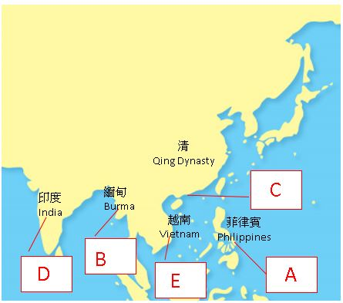

小總結 (A short summary)
清中葉的內憂外患主要包括太平天國之亂、第一次鴉片戰爭和第二次鴉片戰爭。(The Taiping Rebellion, the First Opium War and the Second Opium War were the internal problems and external threats faced by the Qing government in the mid-Qing era.)

如對本教材有任何意見，可聯絡課程發展處個人、社會及人文教育組：
黃浩明先生（erichmwong@edb.gov.hk; 35406829）或
羅嘉恩女士（lokayan@edb.gov.hk; 28925882）

